Paper 1: Google Research Football: A Novel Reinforcement Learning Environment
Contribution: Proposed the new football benchmarks, and give a initial reinforcement learning environment. In terms of methodology, there is not much innovation.
Recommendation: two star/(five star)
Action Space:
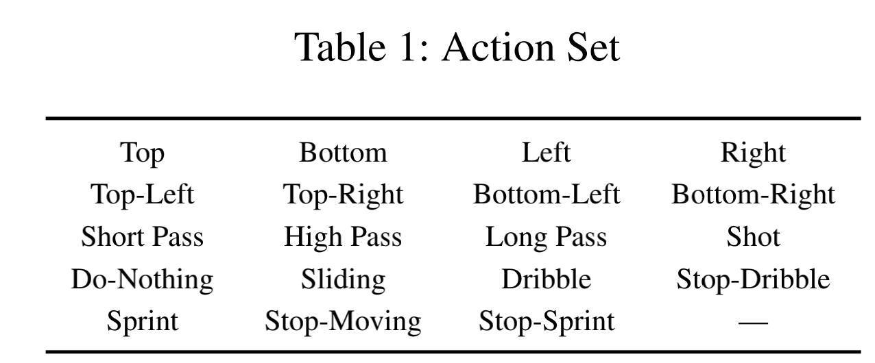
State Space:
We define as state the complete set of data that is returned by the environment after actions are performed. On the other hand, we define as observation or representation any transformation of the state that is provided as input to the control algorithms. The definition of the state contains information such as the ball position and possession, coordinates of all players, the active player, the
game state (tiredness levels of players, yellow cards, score, etc) and the current pixel frame.
Pixels. The representation consists of a 1280 × 720 RGB image corresponding to the rendered screen. This includes both the scoreboard and a small map in the bottom middle part of the frame from which the position of all players can
be inferred in principle.
Super Mini Map. The SMM representation consists of four 72 × 96 matrices encoding information about the home team, the away team, the ball, and the active player respectively. The encoding is binary, representing whether there is a player or ball in the corresponding coordinate.
Floats. The floats representation provides a compact encoding and consists of a 115-dimensional vector summarizing many aspects of the game, such as players coordinates, ball possession and direction, active player, or game mode.
Reward:
The Football Engine includes two reward functions that can be used out-of-the-box: SCORING and CHECKPOINT.
SCORING: corresponds to the natural reward where each team obtains a +1 reward when scoring a goal, and a 1 reward when conceding one to the opposing team. The SCORING reward can be hard to observe during the initial stages of training, as it may require a long sequence of consecutive events: overcoming the defense of a potentially strong opponent, and scoring against a keeper.
CHECKPOINT is a (shaped) reward that specifically addresses the sparsity of SCORING by encoding the domain knowledge that scoring is aided by advancing across the pitch: It augments the SCORING reward with an additional auxiliary reward contribution for moving the ball close to the opponent’s goal in a controlled fashion. More specifically, we divide the opponent’s field in 10 checkpoint regions according to the Euclidean distance to the opponent goal. Then, the first time the agent’s team possesses the ball in each of the checkpoint regions, the agent obtains an additional reward of +0.1. This extra reward can be up to +1, i.e., the same as scoring a single goal.

